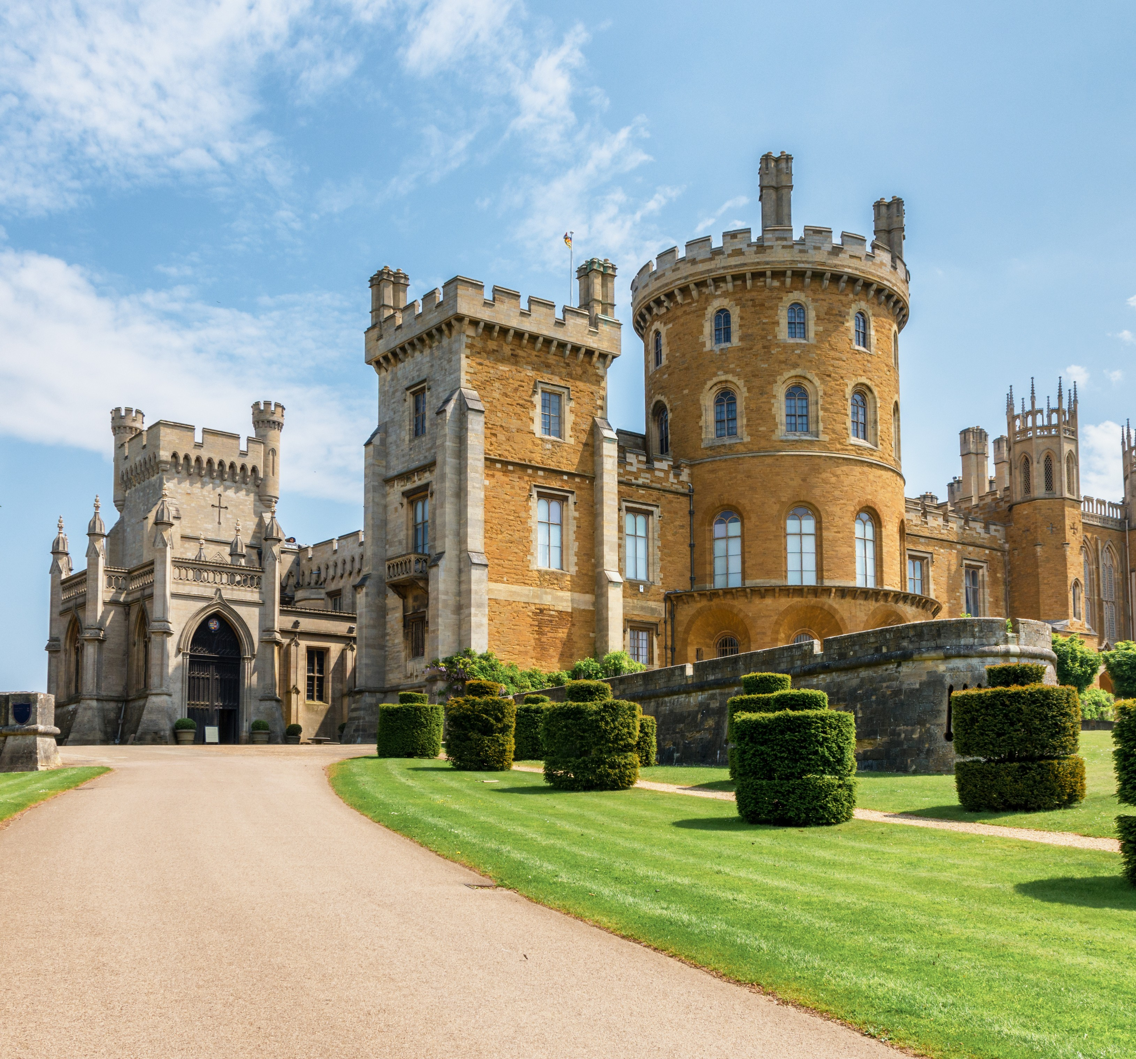

GROUP TOURS
WELCOME TO

Booking Form
Group name: |  |  | Date of visit:
Title: | First name: | Last name:
Address:
Email: |  | Telephone:
Name of group leader: |  |  |  | Group qty:
Time of arrival: |  | Time of departure:
Do you require coach drop off and collection outside the castle?*
Include a visit to the Engine Yard Retail Village?*
Entry Prices: | Castle and gardens open from 11am - 4pm
Please enter your quantity here | adult | quantity |  | child | quantity
School groups (16 & under) | £12.00
School groups (teachers/helpers) | free
Garden entry explore yourself | £9.00 |  |  | £5.00
Garden tour with head gardener | £13.00 |  |  | £9.00
Castle & garden explore yourself | £14.00 |  |  | £8.00
Castle guided tour & garden explore | £18.00 |  |  | £9.00
Refreshment Options | Please select one option only:
SERVED IN THE CASTLE TEAROOM - THE AVIARY |  |  |  | price | quantity
Refreshments on arrival - morning coffee/tea and biscuits |  |  |  | £4.00
Belvoir cream tea - scone with jam & cream, & coffee/tea |  |  |  | £6.00
Aviary afternoon tea - £4 extra to include glass of Prosecco |  |  |  | £15.00
AT THE ENGINE YARD FUEL TANK CAFE - subject to availability |  |  |  | price | quantity
Soup and a sandwich served with crisps, coleslaw & salad |  |  |  | £9.95 | min 12
Buffet: quiches, ploughman’s, Indian samosa selection |  |  |  | £12.95 | min 12
Self serve drinks: tea/coffee, orange & apple juice |  |  |  | £2.95 | min 24
Office use only:
Cost confirmation sent: |  | Booking status:
Payment status: |  | Date of reply:

Event Booking Form

Group name: |  |  | Date of visit:
Title: | First name: | Last name:
Address:
Email: |  | Telephone:
Name of group leader: |  |  |  | Group qty:
Time of arrival: |  | Time of departure:
Do you require coach drop off and collection outside the castle?*
Include a visit to the Engine Yard Retail Village?*
Entry Prices: | Event tickets include castle and garden free flow entry
Please enter your quantity here | adult | quantity |  | child | quantity
28th & 29th May – 1940’s weekend | £20.00 |  |  | £8.00
3rd & 4th June – Queen’s Jubilee | £22.00 |  |  | £10.00
25th & 26th June - Steampunk | £20.00 |  |  | £8.00
23rd & 24th July - English Civil War | £20.00 |  |  | £8.00
6th & 7th August - Napoleonic | £20.00 |  |  | £8.00
3rd & 4th September - Medieval | £20.00 |  |  | £8.00
Please note: Due to the nature of these events it will be busy and we cannot provide group booking lunches. Feel free to bring packed lunches to these events or enjoy the food we have to offer on the day.
Office use only:
Cost confirmation sent: |  | Booking status:
Payment status: |  | Date of reply:

